**Objective** : The expt will have provision to simulate restricted cruise and climb flight by giving designed input.Instrument panel will display few parameters required to compute cruise and climb performance.

**Introduction :** This experiment includes the flight conditions in which cruise flight and climb flight can be performed.In this exp.,the input required by the user for cruise flight is the angle of attack at which the aircraft is required to perform cruise.In case of climb flight, alongwith angle of attack,flight path angle input is required.For climb flight,the value of flight path angle is greater than zero.A controller is required which can perform controlled flights over a wide flight envelope of the flight vehicle.In this exp,the control technique used to design controller is Nonlinear dynamics inversion (NDI).

In case of cruise flight,the required conditions are :

1. All the angular velocities of the aircraft in body frame must be zero.
2. The aircraft should not lose or gain altitude i.e. the flight path angle should be zero.
3. The roll angle and yaw angle should be zero and sideslip angle should be zero.
4. The thrust generated should be equal to drag so that aircraft flies at a constant velocity.

In case of climb flight,the required conditions are :

1. All the angular velocities of the aircraft in body frame must be zero.
2. The aircraft gains altitude i.e. the flight path angle should be greater than zero.
3. The roll angle and yaw angle should be zero and sideslip angle should be zero.
4. The thrust generated should be greater than drag created.

**Apparatus:** An aircraft model,Sensors i.e. Rate gyrometers to measure angular velocities of the aircraft, Accelerometers to measure accelerations in all 3 directions in body frame, Inertial measurement Unit (IMU) to measure the attitude of the aircraft w.r.t. Inertial frame reference point.Global positioning system (GPS) to measure aircraft 3-dimensional position w.r.t. Inertial frame reference point.

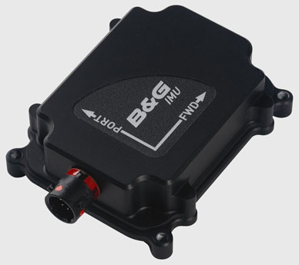 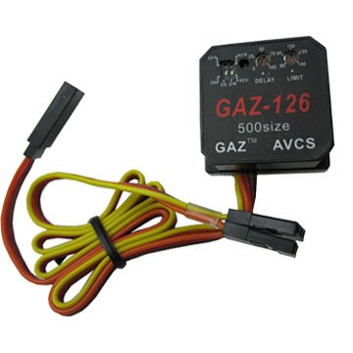

Piezoelectric gyrometer

Inertial measurement Unit (IMU)

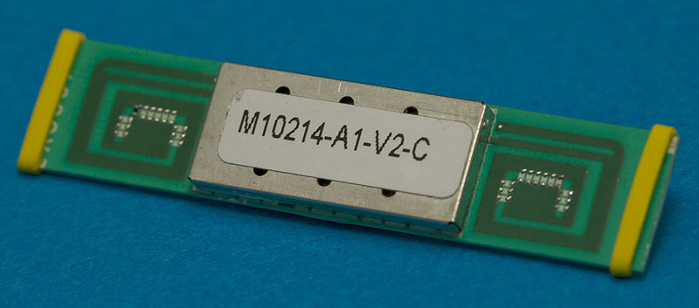

A typical GPS receiver with integrated antenna

**Procedure :**

1. (a) To simulate cruise flight,enter a suitable values of angle of attack at which the user wants the aircraft to trim. Put values of sideslip angle,roll angle,yaw angle zero.Flight path angle should also be zero.

(b) Click the RUN button.

1. (a) To simulate climb flight,enter a suitable values of angle of attack and put values of sideslip angle,roll angle,yaw angle zero.Flight path angle value should be greater than zero.

(b) Click the RUN button.

**Results and Discussions :** The results obtained can be observed in the plots generated for the various flight conditions as desired by the user.

The flight vehicle performs cruise flight and climb flight in a well controlled manner.

**Appendix :** Here is explained the core of the control algorithm that has been used to develop the code.NDI control law is explained how it generates control commands.The control commands are generated based upon the error signal generated from the desired state and current state received from the sensors via feedback path.Any aircraft system can be represented by the following nonlinear vector form dynamics equation

$\dot{x}=a\left(x\right)+b\left(x\right)u$--(1)

$x$ represents the vector representing state variables, $a(x)$ represent nonlinear state dynamic function and $b\left(x\right)$ represent the control distribution function.NDI control law inverts the dynamics equation and then replaces the inherent rate of change of state variable by the desired rate of change of that variable to generate the required command which is fed to the system. Inverting equation (1) we get

$u={b(x)}^{-1}\left[\dot{x}-a\left(x\right)\right]$--(2)

In NDI control algorithm, equation (2) is converted into a form as ${ u}_{d}=b{(x)}^{-1}\left[{\dot{x}}_{d}-a\left(x\right)\right]$--(3) where, ${\dot{ x}}_{d}=k(x_{d}-x)$--(4) $x_{d}$ in equation (4) represents the vector consisting of the desired values of state variables and $x$ represents the vector consisting of the measured values of corresponding state variables obtained via feedback path. $k$ represents state gain matrix whose elements are design parameters of the controller and $u_{d}$ represents the vector consisting of the control commands generated i.e. elevator, aileron, rudder deflection commands and thrust command which are to be fed to the aircraft system as control input.

**Gallery :**